CO-5 ASSISSMENT-5
PART A – DESIGN AND PSEUDOCODE
A1. DISCOURSE AND GENERATION RESPONSIBILITIES
1. Discourse Analysis and Language Generation
Discourse analysis identifies how sentences are connected and how entities are referred to throughout a text. Language generation uses this information to produce meaningful and well-structured sentences.
Main Responsibilities:
- Identify important people, objects and entities.
- Resolve pronouns such as he, she, it and they.
- Identify relationships between sentences.
- Maintain context throughout the text.
- Generate clear sentences without unnecessary repetition.
2. Scheme and Designer
Scheme | Designer
Defines the rules and structure for reference resolution. | Develops and implements the scheme.
Explains how entities and pronouns are connected. | Selects suitable methods and rules.
Provides a systematic approach. | Tests and improves the system.
3. Markables and Evaluation
Markables are words or expressions that refer to entities in a text. They include names, noun phrases and pronouns.
The performance of a coreference resolver is measured using:
- Precision: Correct references divided by total proposed references.
- Recall: Correct references divided by total actual references.
- F1-score: Harmonic mean of precision and recall.
System | Proposed | Correct | Precision
X | 5 | 3 | 0.60
Y | 3 | 3 | 1.00
System Y has higher precision because all its proposed references are correct. Recall and F1-score require the total number of gold-standard references.
4. Pseudocode for Pronoun Resolution
- START
- Read the input text
- Split text into sentences
- Identify nouns and pronouns
- FOR each pronoun:
- Find possible noun references
- Check gender and number
- Check sentence context
- Select the most suitable reference
- Link the pronoun to the entity
- Display resolved references
- STOP
5. Reference Resolution in Text T
The given text describes a department purchasing a server, Ravi configuring it, a compiler suite crashing and a vendor replacing a module.
The resolver performs the following steps:
- Identify the department, server, Ravi, compiler suite, vendor and module.
- Identify pronouns and referring expressions in the six sentences.
- Find possible antecedents for each pronoun.
- Check grammatical agreement and sentence meaning.
- Connect each pronoun with its correct entity.
- Maintain the references throughout the text.
Result: Discourse analysis helps identify relationships between entities and pronouns and improves text understanding.
A2. DISCOURSE SEGMENTATION AND STRUCTURE
1. Discourse Segmentation
Discourse segmentation divides a text into smaller meaningful units. Each unit represents an event, statement or idea.
It helps identify how sentences are connected and how information is organized.
2. Types of Discourse Relations
Relation | Meaning
Cause | One event produces another event.
Explanation | Gives a reason for a statement.
Contrast | Shows differences between ideas.
Elaboration | Provides additional information.
Sequence | Shows the order of events.
3. Discourse Graph
A discourse graph represents the relationships between different text units.
It contains:
- Nucleus: The main or important information.
- Satellite: Information that supports the main information.
- Predecessor: The previous discourse unit.
- Successor: The following discourse unit.
- Right Frontier: The set of discourse units that can receive new attachments.
4. Pseudocode for Discourse Segmentation
- START
- Read the complete text
- Divide text into sentences
- Identify meaningful discourse units
- FOR each unit:
- Identify its main information
- Find its supporting information
- Identify its relation with other units
- Add the relation to the discourse graph
- Update predecessor and successor
- Maintain the right frontier
- Display the discourse graph
- STOP
5. Backward Reference Search
When a pronoun appears, the system searches previous discourse units to find a suitable entity.
Steps:
- Read the current pronoun.
- Search previous sentences backwards.
- Identify possible entities.
- Check number, gender and meaning.
- Select the most suitable entity.
6. Common Challenges
- A pronoun may have multiple possible references.
- Long sentences may contain several relationships.
- Missing context can create confusion.
- Incorrect segmentation may affect the discourse graph.
- Implicit relationships may be difficult to identify.
Result: Discourse segmentation organizes text into meaningful units and represents their relationships using a discourse graph.
A3. GENERATION MEMORY AND REFERENCE CHOICE
1. Generation Memory
Generation memory stores information about entities that have already been mentioned. It helps the system select suitable expressions when generating new sentences.
2. Main Components
Component | Description
Focus List | Stores recently mentioned entities.
Descriptor | Stores names and descriptions of entities.
Aggregation Buffer | Stores information that can be combined into one sentence.
Given/New Flag | Identifies whether information is already known or newly introduced.
3. Focus List with k = 2
A focus list with k = 2 stores the two most recently relevant entities.
For example:
Mention | Focus List
Ravi | Ravi
Server | Server, Ravi
Vendor | Vendor, Server
When a new entity is introduced, the least relevant entity may be removed to maintain the limit.
4. Reference Selection
The system follows these rules:
- If the entity is already in focus, use a suitable pronoun.
- If a free focus slot is available, add the new entity.
- If the focus list is full, remove the least relevant entity.
- If another entity has the same gender, use a clearer description.
- If the entity is new, introduce it using a noun phrase.
5. Aggregation
Aggregation combines related information into a single sentence.
Example:
Separate sentences:
- Ravi opened the report.
- Ravi checked the report.
Combined sentence:
- Ravi opened and checked the report.
6. Generation Memory Trace
The following table shows how generation memory is updated across four stages.
Stage | Memory Operation | Result
F1 | Introduce a new entity | Add entity to focus list.
F2 | Refer to an existing entity | Use a suitable pronoun or description.
F3 | Introduce another entity | Update the focus list.
F4 | Update focus and aggregate information | Generate a clear sentence.
7. Comparison of Generation Methods
Method | Description
Naive Generation | Repeats entity names frequently.
Memory-Based Generation | Uses stored context and suitable references.
Handwritten Generation | Uses human understanding to create natural sentences.
Memory-based generation reduces unnecessary repetition and improves sentence flow.
8. Failure Case
A pronoun may become confusing when two entities have the same gender or number.
Example: Ravi spoke to Arun after he completed the task.
The pronoun "he" may refer to Ravi or Arun. Using the person's name instead makes the sentence clearer.
Result: Generation memory improves reference selection, reduces repetition and produces more natural text.
Re-introduction | Repeated Reference
An entity is mentioned again after being less active in the discourse. | An entity is referred to again in the current context.
A full noun phrase may be required. | A pronoun may be sufficient.
Helps restore an entity to focus. | Maintains continuity.
3. Types of References
- Anaphora: A reference to an entity mentioned earlier.
- Cataphora: A reference to an entity introduced later.
- One-anaphora: Uses the word "one" to refer to a previously mentioned noun.
- Implicit Causal Relation: A cause-and-effect relationship is understood without an explicit connecting word.
4. Pseudocode for Entity–Discourse Analysis
- START
- Read the input text
- Split text into sentences
- Identify noun phrases and pronouns
- FOR each reference:
- Search existing entities
- Check grammatical agreement
- Check semantic context
- IF a matching entity exists:
- Link the reference to that entity
- ELSE:
- Create a new entity
- Identify discourse relations
- Update the entity-disourse graph
- Display the graph
- STOP
5. Rewrite Rules
Situation | Rule
Existing entity is clear | Use a pronoun.
Entity is unclear | Use the full noun phrase.
Entity is introduced for the first time | Use a descriptive noun phrase.
Two entities may be confused | Repeat the entity name.
A causal relation is present | Represent the cause-and-effect connection.
6. Challenges in Discourse Analysis
- Quotation: A pronoun inside a quotation may refer to a different speaker or entity.
- Section Heading: A heading may introduce a new topic without a complete sentence.
- Gender Loss in Translation: Some languages do not preserve gender information in the same way as English.
- Same Noun, Different Entity: The same noun may refer to different objects in different contexts.
- Implicit Relations: Some relationships are understood but not directly stated.
Result: Entity–discourse graphs improve reference identification and help the system understand connections between sentences.
A5. DISCOURSE TECHNIQUES AND DATA-FLOW ANALYSIS
1. Important Discourse Techniques
Technique | Purpose
Coreference Chains | Connect expressions that refer to the same entity.
Lexical Chains | Connect related words based on meaning.
Centering Theory | Tracks the main entities in a sequence of sentences.
Entity Grid | Represents how entities appear across sentences.
Discourse Extraction | Identifies meaningful units and relationships.
Distributional Similarity | Identifies words with similar meanings using context.
2. Applications and Safety Conditions
These techniques are useful for text summarization, question answering, translation and document analysis.
However, they require:
- Correct sentence segmentation.
- Reliable identification of entities.
- Sufficient surrounding context.
- Proper handling of ambiguous references.
- Careful checking of automatically predicted relationships.
3. GEN/KILL Analysis
GEN/KILL analysis is a data-flow technique used to identify information generated and removed during program execution.
- GEN: Information generated by a statement.
- KILL: Information removed or made invalid by a statement.
- IN: Information available before a statement.
- OUT: Information available after a statement.
4. GEN/KILL Equations
For a forward analysis:
IN[n] = Union of OUT values of predecessors
OUT[n] = GEN[n] ∪ (IN[n] − KILL[n])
For a backward analysis, information flows from successors towards predecessors. The equations depend on the specific analysis being performed.
5. GEN/KILL Pseudocode
- START
- Initialize IN and OUT sets
- REPEAT
- FOR each statement:
- Calculate IN using predecessor information
- Calculate OUT using GEN and KILL
- Update all sets
- UNTIL no set changes
- Display final IN and OUT values
- STOP
6. Iteration Table
Iteration | IN Set | OUT Set | Status
1 | Initial values | Calculated values | Changed
2 | Updated values | Recalculated values | Changed
3 | Updated values | Recalculated values | Check
Final | Stable values | Stable values | Fixed point reached
The analysis continues until no IN or OUT set changes. This stable condition is called a fixed point.
7. Presupposition Analysis
Presupposition analysis identifies information that a sentence assumes to be true.
For example:
Sentence: Ravi stopped using the old computer.
Presupposition: Ravi used the old computer earlier.
The system should identify such information carefully and avoid making unsupported assumptions.
8. Importance of Conservative Analysis
- Avoids creating unsupported information.
- Reduces incorrect reference identification.
- Maintains the original meaning of the text.
- Improves the reliability of generated sentences.
- Helps produce accurate summaries and answers.
Result: Discourse techniques and GEN/KILL analysis help organize information, track references and maintain context. Conservative analysis reduces incorrect interpretations.

PART B – IMPLEMENTATION AND INVESTIGATION
1. IMPLEMENTATION OF A DISCOURSE ANALYSER
1. AIM
To develop a discourse analyser that identifies entities, detects pronouns and resolves references using sentence context.
2. SYSTEM DESCRIPTION
The discourse analyser processes a given text and identifies important entities and referring expressions. It uses grammatical agreement and contextual information to connect pronouns with their possible antecedents.
3. MAIN COMPONENTS
- Text Processing: Divides the input text into meaningful sentences.
- Entity Identification: Identifies people, objects and important nouns.
- Pronoun Detection: Identifies pronouns used in the text.
- Reference Resolution: Connects pronouns with suitable entities.
- Context Management: Maintains previously mentioned entities.
4. VERSION COMPARISON
Version | Method | Description
Version 1 | Recent Mention | Selects the most recently mentioned compatible entity.
Version 2 | Reasoned Salience | Considers context, grammatical agreement and entity importance.
5. FOCUS WINDOW COMPARISON
Window Size | Description
k = 1 | Considers only the most recent entity.
k = 2 | Considers two recent entities.
k = 3 | Considers three recent entities.
Unlimited | Considers all previously mentioned entities.
6. TESTING AND INSTRUMENTATION
The system is evaluated using different text samples containing nouns, pronouns and multiple entities.
The following details are recorded:
- Total number of sentences.
- Number of entities identified.
- Number of pronouns detected.
- Correctly resolved references.
- Incorrectly resolved references.
- Processing time.
7. OBSERVATION
The recent-mention method is simple and fast but may select an incorrect entity. The reasoned-salience method provides better contextual understanding by considering grammatical and semantic information.
RESULT: A discourse analyser design was developed to identify entities and resolve pronouns using contextual information.
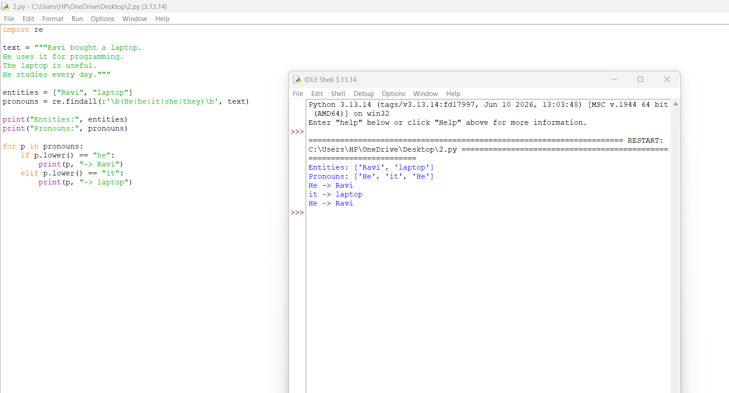
2. ADVERSARIAL TEXT TESTING
1. AIM
To evaluate the performance of a discourse analyser using challenging texts containing ambiguous pronouns and multiple possible references.
2. TEST CASES
TEST CASE 1 – TWO MALE ENTITIES
Ravi met Arun in the library. He was carrying a book. Arun spoke to Ravi. He explained the assignment. Ravi listened carefully. He thanked Arun.
Challenge: The pronoun "He" may refer to Ravi or Arun. The system must consider the sentence context.
TEST CASE 2 – TWO FEMALE ENTITIES
Meena met Priya after class. She had completed the project. Priya showed Meena a report. She explained the results. Meena checked the report. She found an error.
Challenge: The pronoun "She" may refer to Meena or Priya. Correct interpretation requires contextual analysis.
TEST CASE 3 – DIFFERENT ENTITY TYPES
The teacher spoke to the student. He asked a difficult question. The student opened a notebook. It contained important notes. The teacher checked the answer. He appreciated the effort.
Challenge: The system must identify the correct person or object based on grammatical agreement and sentence meaning.
3. TESTING PROCEDURE
- Prepare six-sentence text samples.
- Identify all pronouns in each sample.
- Find possible antecedents.
- Compare predicted references with manually identified correct references.
- Record correct and incorrect predictions.
- Calculate precision, recall and F1-score.
4. EVALUATION METRICS
- Precision: Measures how many predicted references are correct.
- Recall: Measures how many actual references are correctly identified.
- F1-score: Measures the balance between precision and recall.
5. COMPARISON
Test Case | Main Challenge | Required Analysis
Test 1 | Two male entities | Context-based identification
Test 2 | Two female entities | Correct antecedent selection
Test 3 | Person and object references | Grammatical agreement
6. OBSERVATION
Adversarial testing shows that pronoun resolution becomes difficult when multiple entities have similar grammatical properties. A system that uses only the nearest noun may produce incorrect results.
RESULT: The discourse analyser was evaluated using ambiguous texts to understand its strengths and limitations.
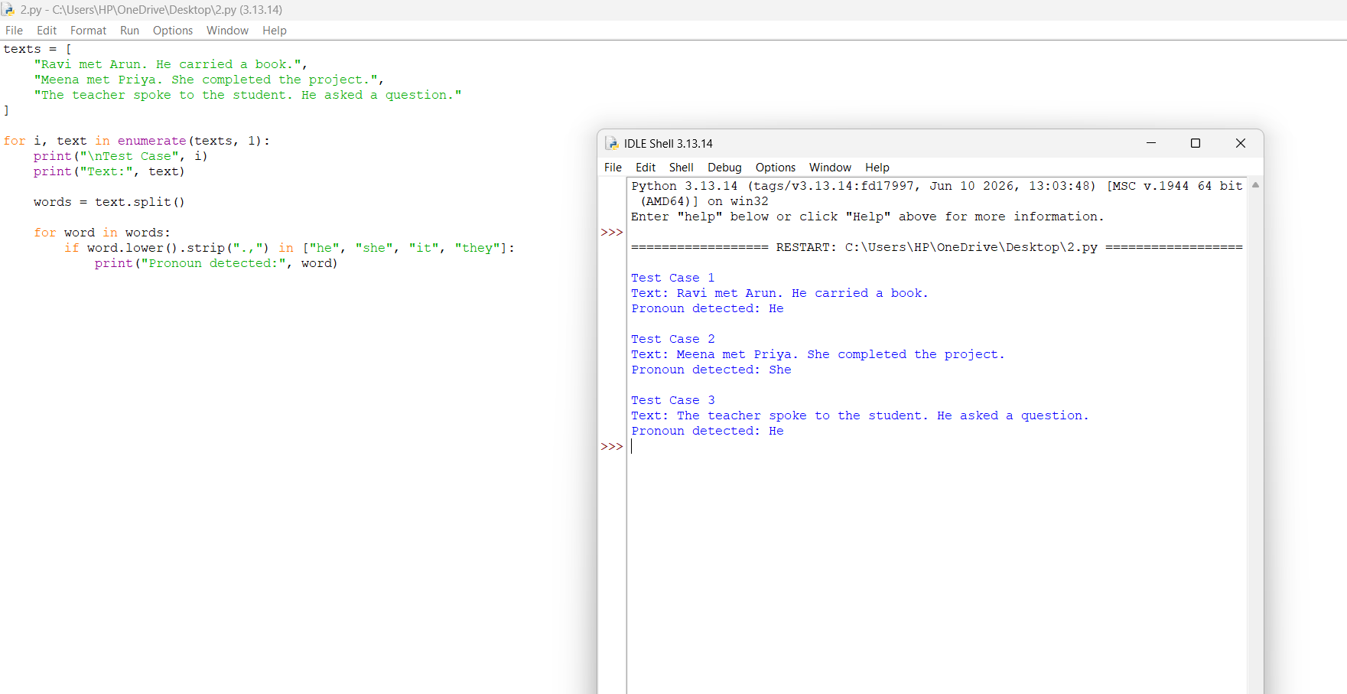

3. DIALOGUE ACT CLASSIFICATION AND STATE TRACKING
1. AIM
To classify dialogue sentences into different dialogue acts and maintain conversation information across multiple turns.
2. DIALOGUE ACT TYPES
Dialogue Act | Description
Greeting | Starts a conversation.
Request | Asks for a service or action.
Question | Requests information.
Inform | Provides information.
Confirmation | Confirms previously given information.
Closing | Ends the conversation.
3. SYSTEM COMPONENTS
- Dialogue Input: Receives the conversation between users.
- Act Classification: Identifies the purpose of each sentence.
- Entity Identification: Identifies important names and objects.
- State Tracking: Stores important conversation details.
- Response Management: Uses the stored information to maintain conversation flow.
4. DIALOGUE STATE TRACKING
Dialogue state tracking maintains important information from previous conversation turns.
Turn | Dialogue Purpose | Updated State
1 | Greeting | Conversation started
2 | Book renewal request | Renewal requested
3 | Due-date question | Due date requested
4 | Due-date information | Due date updated
5 | Closing | Conversation ended
5. THREE DIALOGUE TEST SCENARIOS
Scenario | Purpose
Dialogue 1 | Library book renewal
Dialogue 2 | Asking for book availability
Dialogue 3 | Asking for library opening hours
These scenarios help test whether the system can identify dialogue acts and maintain the correct conversation state.
6. STATE TRACKING METHODS
Method | Description
Full History | Uses all previous conversation turns.
Window-Based | Uses only a limited number of recent turns.
Stack-Based | Stores and updates conversation information in an organized manner.
7. SCALABILITY AND LIMITATIONS
- Full history provides more context but requires more memory.
- Window-based tracking is faster but may lose older information.
- Stack-based tracking organizes conversation details.
- Keyword-based classification may fail when users express the same meaning in different words.
- Long conversations require efficient state management.
8. OBSERVATION
Dialogue act classification identifies the purpose of each sentence, while dialogue state tracking maintains important information across conversation turns.
RESULT: A dialogue classification and state tracking approach was designed for library-related conversations.
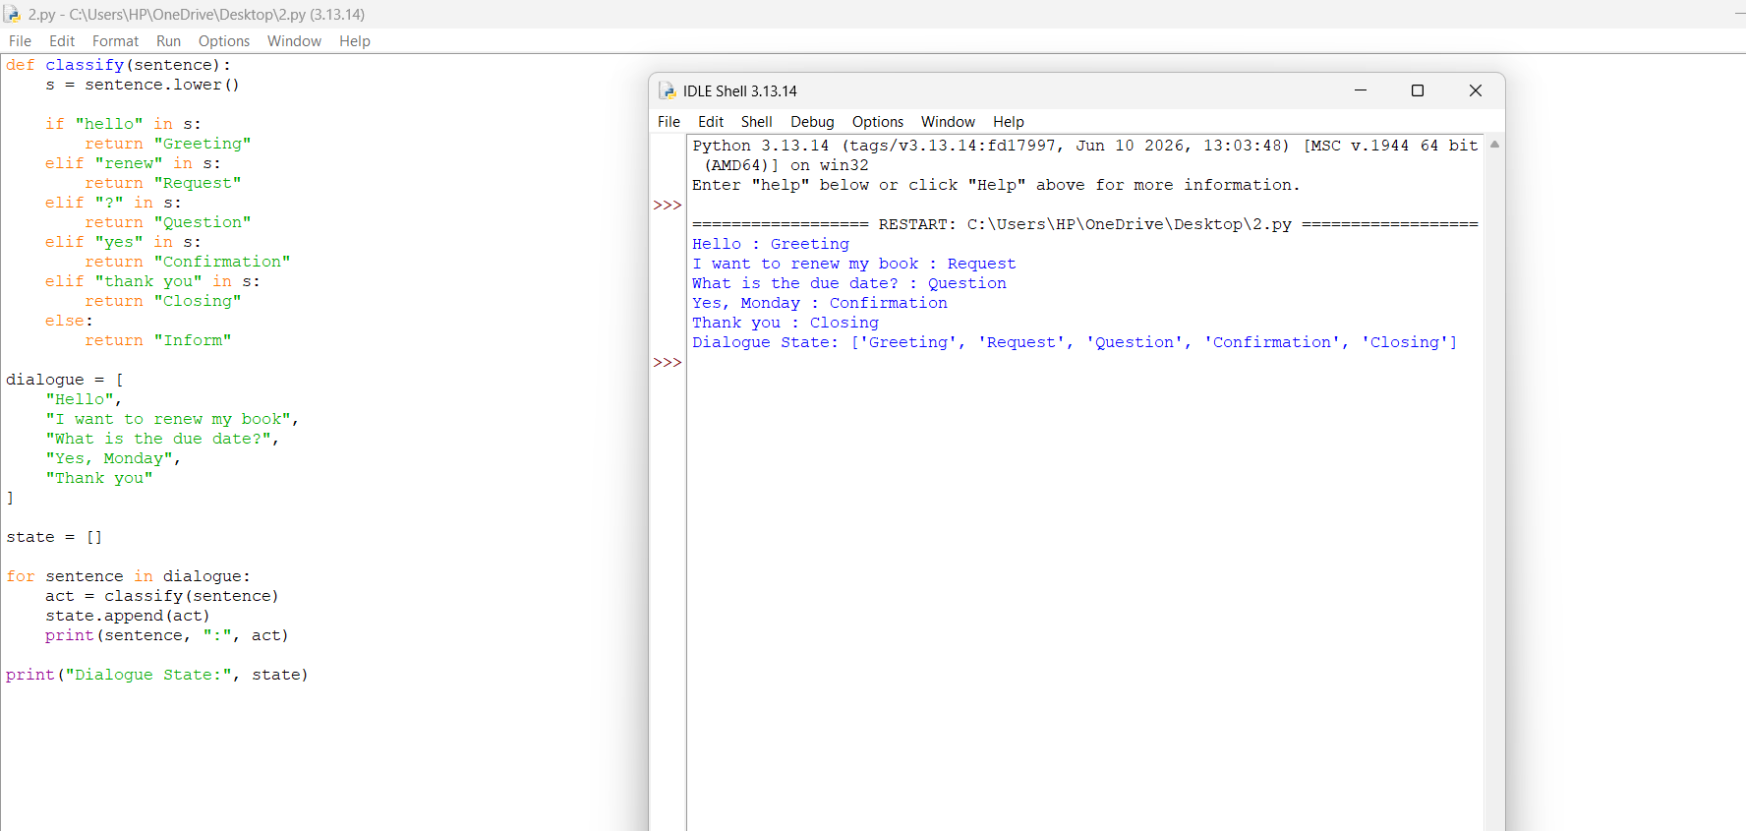
4. DISCOURSE PROCESSING FOR TRANSLATION AND QUESTION ANSWERING
1. AIM
To study how different levels of discourse processing improve translation and question-answering systems.
2. PROCESSING LEVELS
Level | Method | Description
Level 1 | No Discourse | Processes each sentence independently.
Level 2 | Fast Processing | Uses recent context and basic reference resolution.
Level 3 | Full Processing | Uses complete context, coreference and discourse relations.
3. APPLICATIONS
1. MACHINE TRANSLATION
Discourse processing helps identify pronoun references and maintain the original meaning across translated sentences.
2. QUESTION ANSWERING
It helps the system understand previous sentences and provide answers based on the complete context.
3. TEXT SUMMARIZATION
It identifies important entities and relationships to generate meaningful summaries.
4. EVALUATION METRICS
Metric | Purpose
BLEU | Measures similarity between generated and reference translations.
chrF | Measures character-level similarity.
Human Adequacy | Evaluates whether the original meaning is preserved.
Pronoun Count | Measures the number of pronouns in the text.
Processing Time | Measures the time required for processing.
5. COMPARISON OF PROCESSING LEVELS
Processing Level | Context Used | Expected Performance
Level 1 | No previous context | Basic
Level 2 | Recent context | Improved
Level 3 | Complete discourse context | More context-aware
Actual performance must be measured using test data. BLEU and chrF scores should be calculated using reference translations and generated translations.
6. COUNTEREXAMPLE
Sentence: Ravi met Arun because he needed help.
The pronoun "he" may refer to Ravi or Arun. A system without sufficient context may select the wrong person.
This example shows the importance of discourse processing in understanding sentence relationships.
7. DECISION NOTE
- No discourse processing is suitable for simple independent sentences.
- Fast processing is useful when processing speed is important.
- Full processing is useful when accuracy and complete context are required.
- The selection depends on the application and available computational resources.
8. OBSERVATION
Discourse processing improves the understanding of references and relationships between sentences. Full processing provides better contextual information, while fast processing reduces computational effort.
RESULT: Different discourse processing levels were studied and compared for machine translation and question-answering applications.


